**MINIKUBE INSTALLATION**

**Steps to install**

**Step 1:**

1. Create one instance

* Select ubuntu flavor
* Select instance type as t2 medium
* Finally launch the instances

1. Connect the instance to the server
2. Switch to root user by the command **sudo-i**
3. Update the server by the command **apt update -y**

**Step 2:**

1. Installation of **docker** by the commands

|  |
| --- |
| **sudo apt install curl wget apt-transport-https -y** |
| **sudo curl -fsSL https://get.docker.com -o get-docker.sh** |
| **chmod 777 get-docker.sh** |
| **sh get-docker.sh** |

1. Perform these commands one by one in terminal to install the docker services

**Step 3:**

1. Installation of **minikube** by the commands

|  |
| --- |
| **sudo curl -LO https://storage.googleapis.com/minikube/releases/latest/minikube-linux-amd64** |
| **sudo mv minikube-linux-amd64 /usr/local/bin/minikube** |
| **sudo chmod +x /usr/local/bin/minikube** |
| **sudo minikube version** |

1. Perform these commands one by one in terminal to install the minikube services

**Step 4:**

1. Installation of kubectl by the commands

|  |
| --- |
| **sudo curl -LO "https://dl.k8s.io/release/$(curl -L -s https://dl.k8s.io/release/stable.txt)/bin/linux/amd64/kubectl"** |
| **sudo curl -LO "https://dl.k8s.io/$(curl -L -s https://dl.k8s.io/release/stable.txt)/bin/linux/amd64/kubectl.sha256"** |
| **udo echo "$(cat kubectl.sha256) kubectl" | sha256sum --check** |
| **sudo install -o root -g root -m 0755 kubectl /usr/local/bin/kubect** |
| **sudo install -o root -g root -m 0755 kubectl /usr/local/bin/kubectl** |
| **sudo kubectl version --client --output=yaml** |
| **sudo minikube start --driver=docker --force** |

1. Perform these commands one by one in terminal to install the kubectl services

**Step 5:**

1. Create the pod by the command

|  |
| --- |
| **kubectl run pod-name --image=image-name** |

1. Create the yaml file by the command **vi file-name.yml**
2. 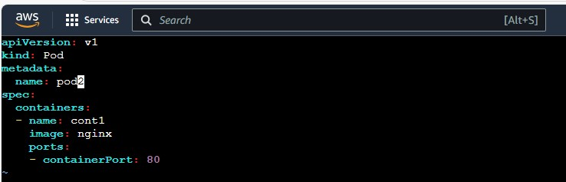Write the script in the yml editor as shown in below figure
3. After writing the script in editor save the editor
4. **Kubectl create -f filename.yml -** by this command if pod is created then the work is done
5. **Kubectl get pods –** it is used to see the created pods as shown in below figure

